Lesson 11. Practice Project: Optimizing University Database

Scenario
The university needs a comprehensive database to keep track of its students, program enrolments, courses, and academic progress. The current database lacks the sophistication required for a large tertiary institution. You are an analyst, tasked with designing a new database system for the university.
Task
Your task is to list the entities, attributes, and relationships among them for the university database, and create an ER (Entity-Relationship) diagram that represents these relationships. State the type of relationships present in the data.
Action
- List the entities, attributes, and relationships in the university database.
- Create an ER diagram for the database and summarize the relationships.

Answer
This document presents the newly designed database structure for the university, created to easily manage student records, courses, and academic processes:
- Student: Created to keep all personal details and contact information of the students in one central place.
- Program: Created to manage the different academic majors and programs offered by the university.
- Courses: Created to store the list and details of all subjects taught at the institution.
- Program_Enrollment: Created to track which student is enrolled in which academic program.
- Course_Enrollment: Created to track which classes students have taken and record their grades.

- Entity: Student
  - Attributes:
    - StudentID (unique identifier)
    - FirstName
    - LastName
    - Email
    - StartDate
- Entity: Program
  - Attributes:
    - ProgramID (unique identifier)
    - ProgramName
    - Department
- Entity: Course
  - Attributes:
    - CourseID (unique identifier)
    - CourseName
    - Credits
- Entity: Program_Enrollment
  - Attributes:
    - EnrolmentID (unique identifier)
    - StudentID (link to the Student entity)
    - ProgramID (link to the Program entity)
    - Program_enroll_date
- Entity: Course_Enrolment
  - Attributes:
    - RecordID (unique identifier)
    - StudentID (link to the Student entity)
    - CourseID (link to the Course entity)
    - Course_enroll_date
    - Grade

ER diagram for the database

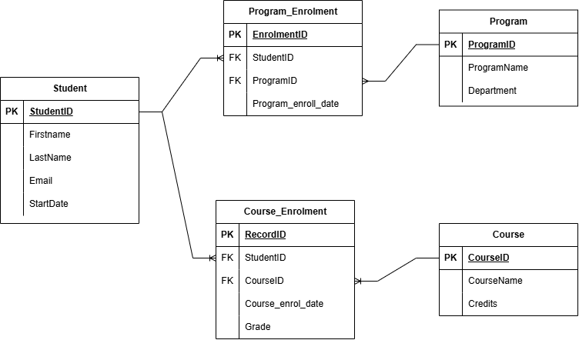
https://app.diagrams.net/

